Create Node-RED Service

|  |  |
| --- | --- |
| **Date** | 13 NOVEMBER 2022 |
| **Team ID** | PNT2022TMID07369 |
| **Project Name** | GAS LEAKAGE MONITORING AND ALERTING SYSTEM FOR INDUSTRIES |

**Aim**:

To create a web application, create a Node-RED service.

# Steps to be followed

Step 1: Navigated to the App creation page.

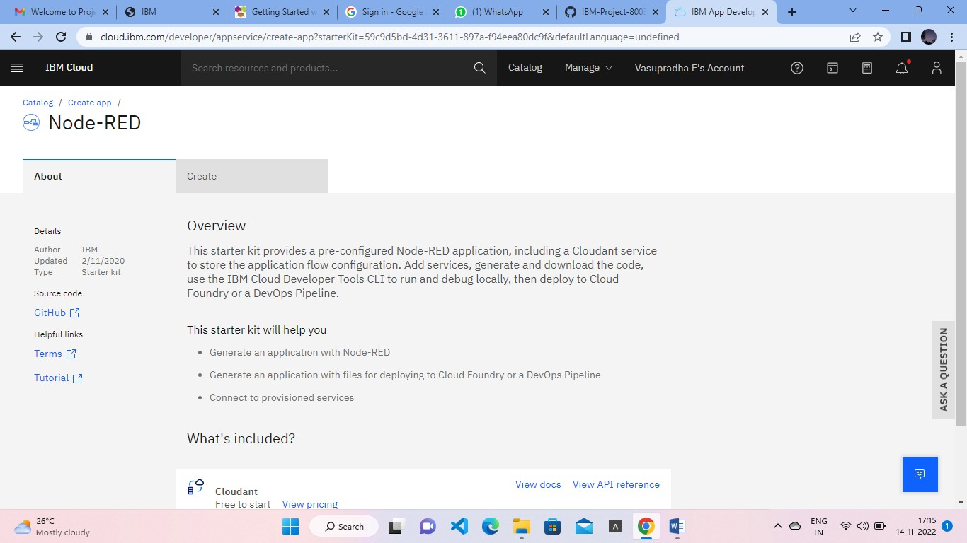

Step 2: Entered project details and clicked on create

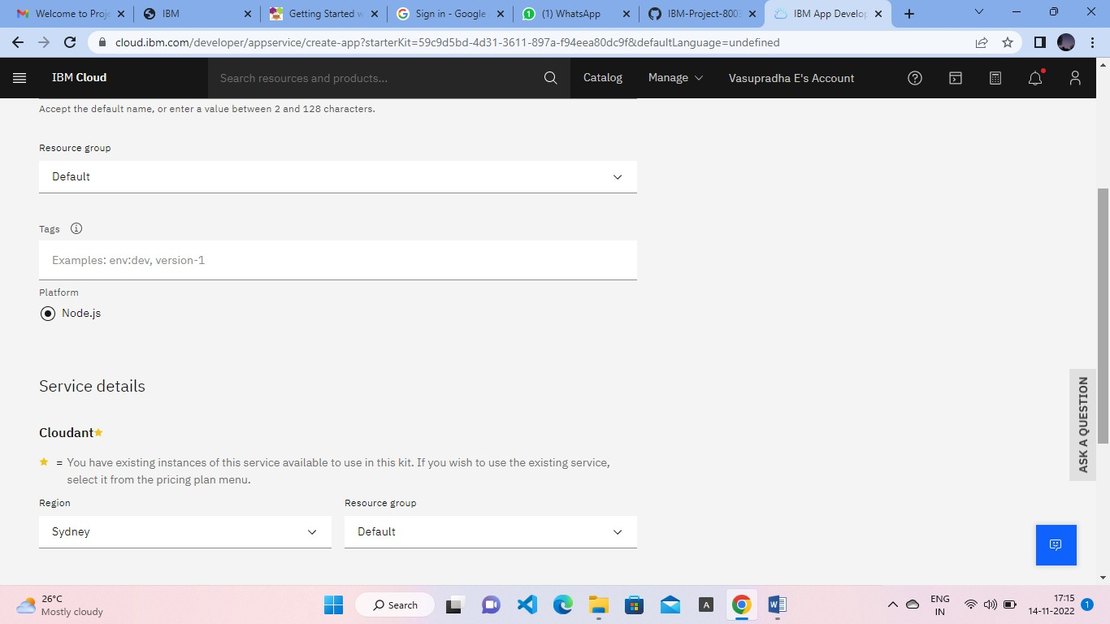

Step 3: Clicking on the “Deploy your App” Button.

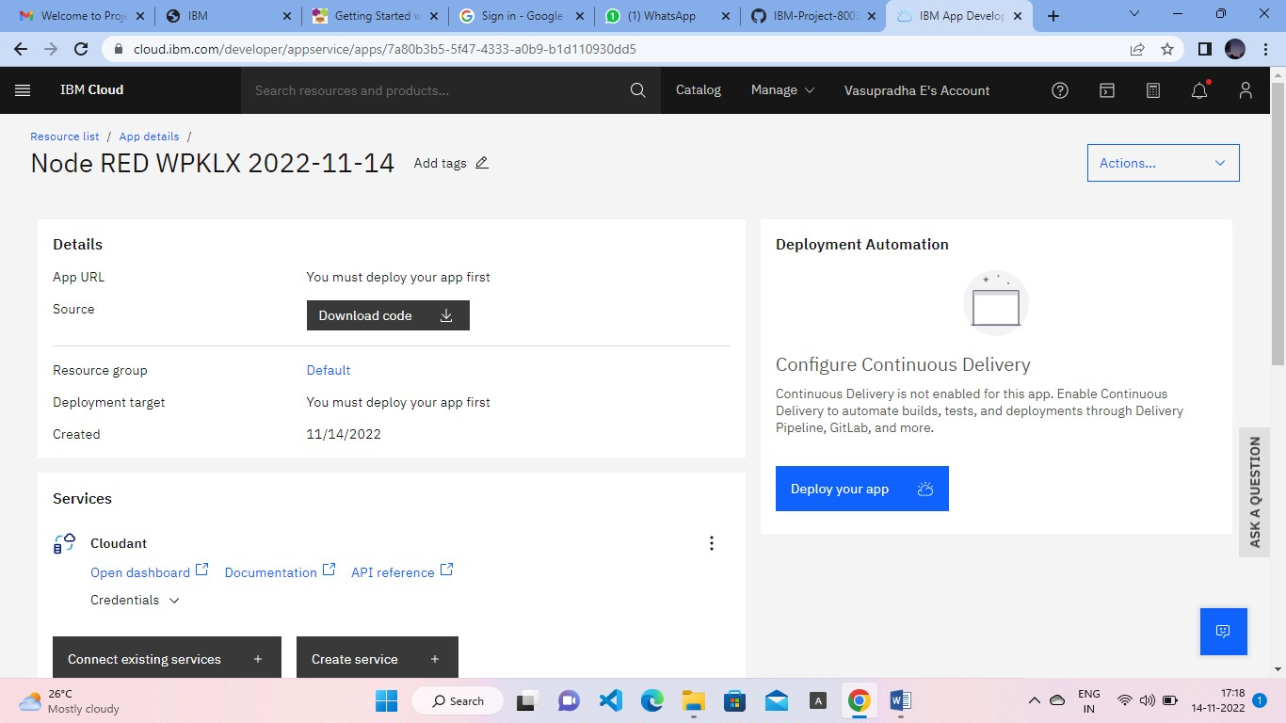

Step 4: Setting up the environment and deploying the app.

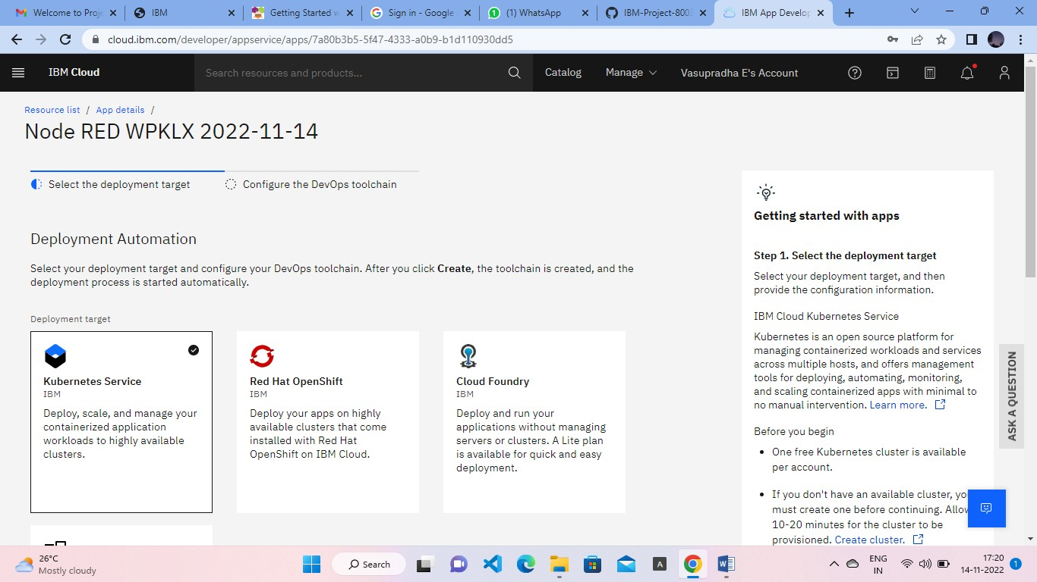

Step 5: Successfully deployed the app.

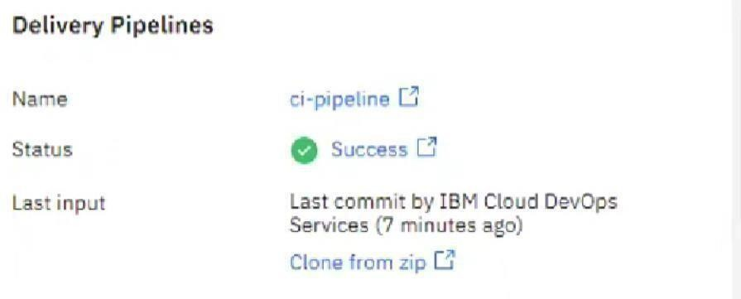

Step 6: Dragged and dropped components into the editor.

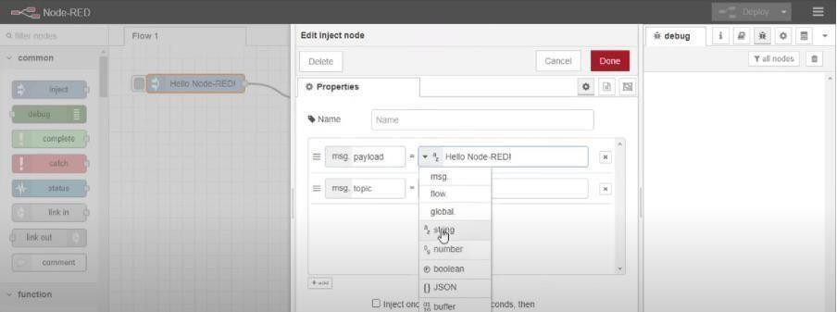

Step 7: Editing some values of the properties.

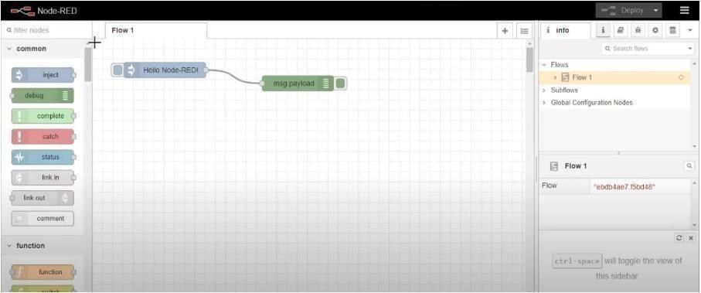

Step 8: Successfully deployed the app.

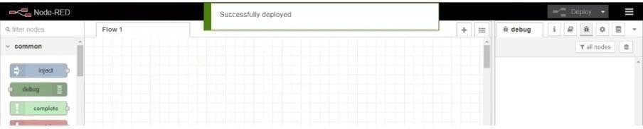

# Result:

Successfully created a Node RED service on IBM Cloud.